Laporan Praktikum 2

1. Source Code

latihan1.php -> controllers

latihan2.php -> controllers

Model1.php -> model

View_latihan2 – views

1. URL

<http://localhost/pustaka_booking_zaerina/latihan1>

<http://localhost/pustaka_booking_zaerina/latihan2/penjumlahan/3/4>

1. Capture Hasil

Latihan 1

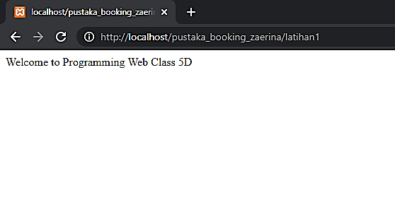

Latihan 2

